IEEE WIE Project 2

**May, 2021**

**Ananya Ghosh**

**20MIC0063**

# Report

**IOT BASED INTEGRATED HEALTHCARE SYSTEM DEVICE**

**Problem:**

* Lack of proper healthcare at home for all, especially old-aged.
* It is a problem for the family members to take proper care of a paralyzed patient.
* It is inconvenient for both patient and family members to always regularly take the old people or paralyzed person for medical check-up and tests.
* Due to insufficient health check-ups and routine check-ups, many people die with common diseases like heart attacks, diabetes, pressure fluctuations due to ignorance and not being diagnosed at proper time.
* Costly medical equipment and tests.

**Solution:**

* **IOT BASED INTEGRATED HEALTHCARE SYSTEM DEVICE**
* **Hardware-**

Containing the sensors for various health parameters checking and measurement:

* **Body Temperature**-Temperature Sensor LM35

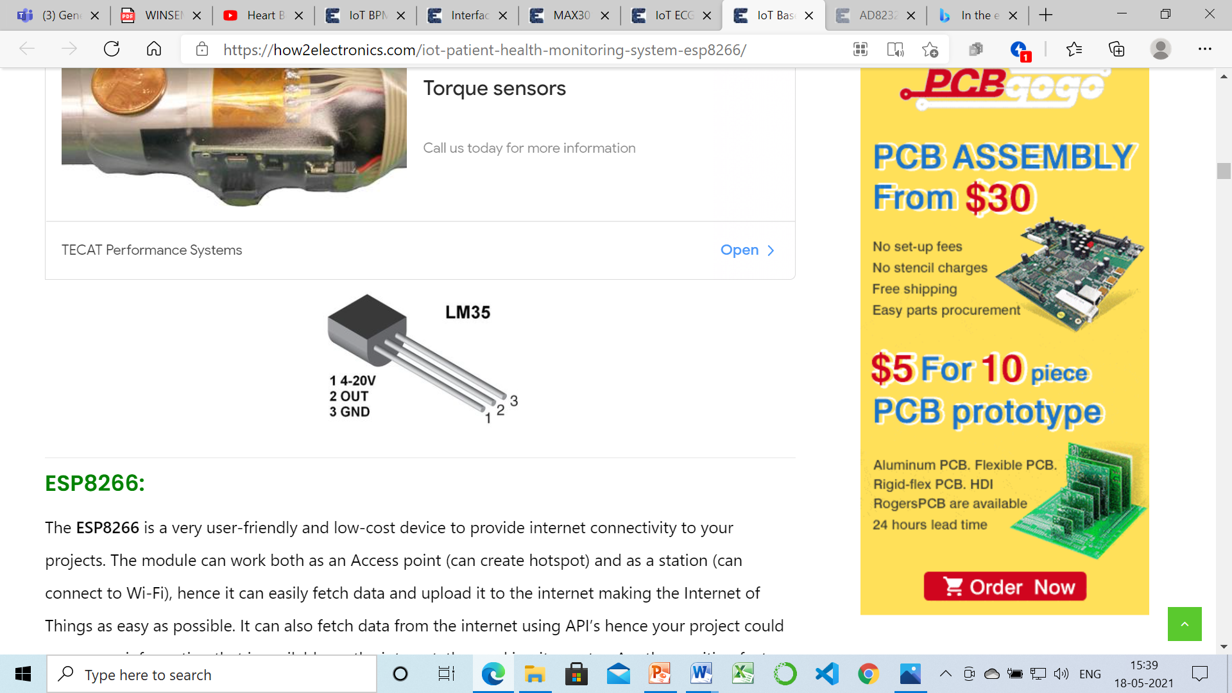

* **Alcohol Detection**- SEN20 MQ-3 High Sensitivity Alcohol Detector Sensor

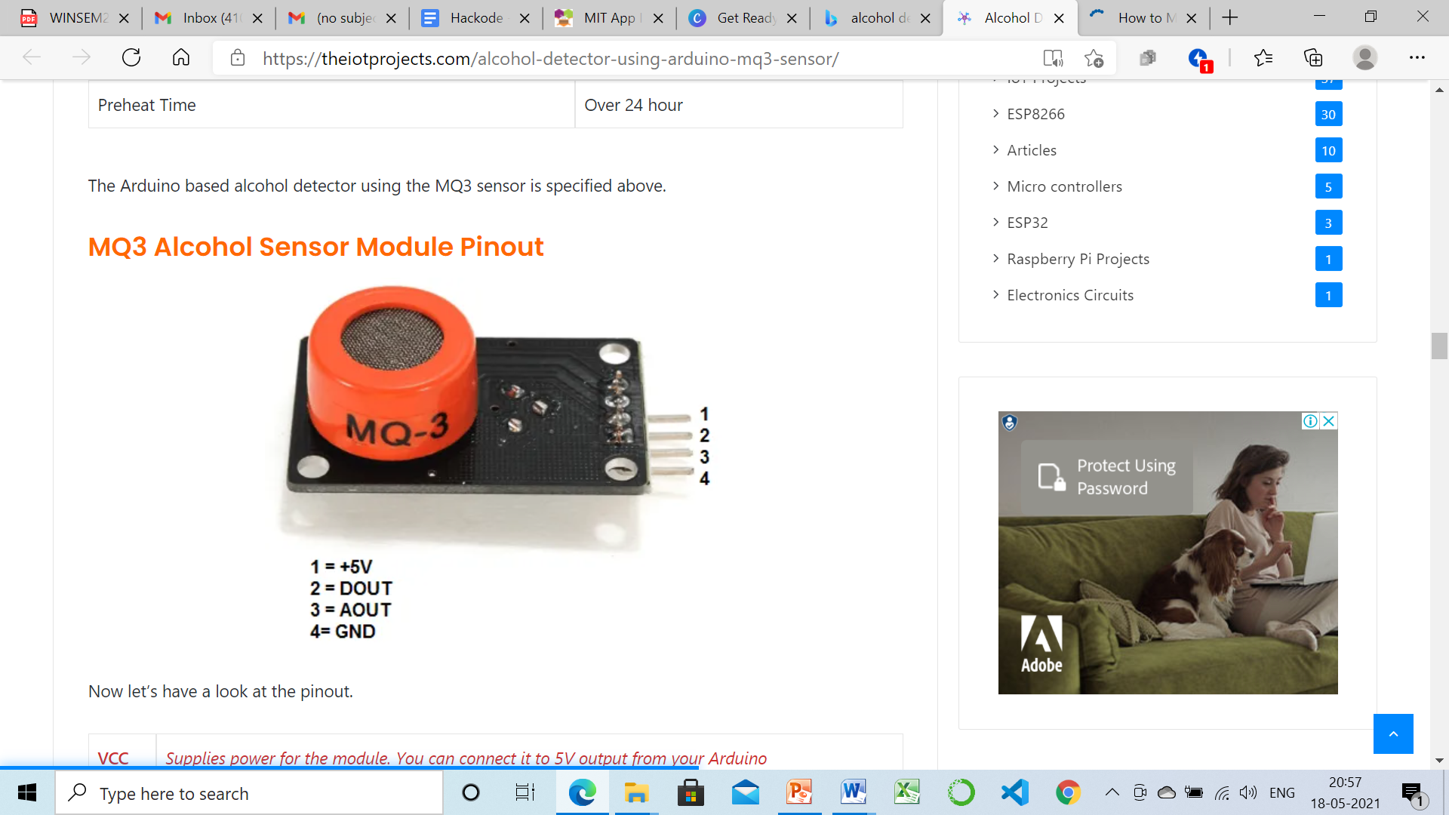

* **Pulse**- Heart Rate Pulse Sensor Module

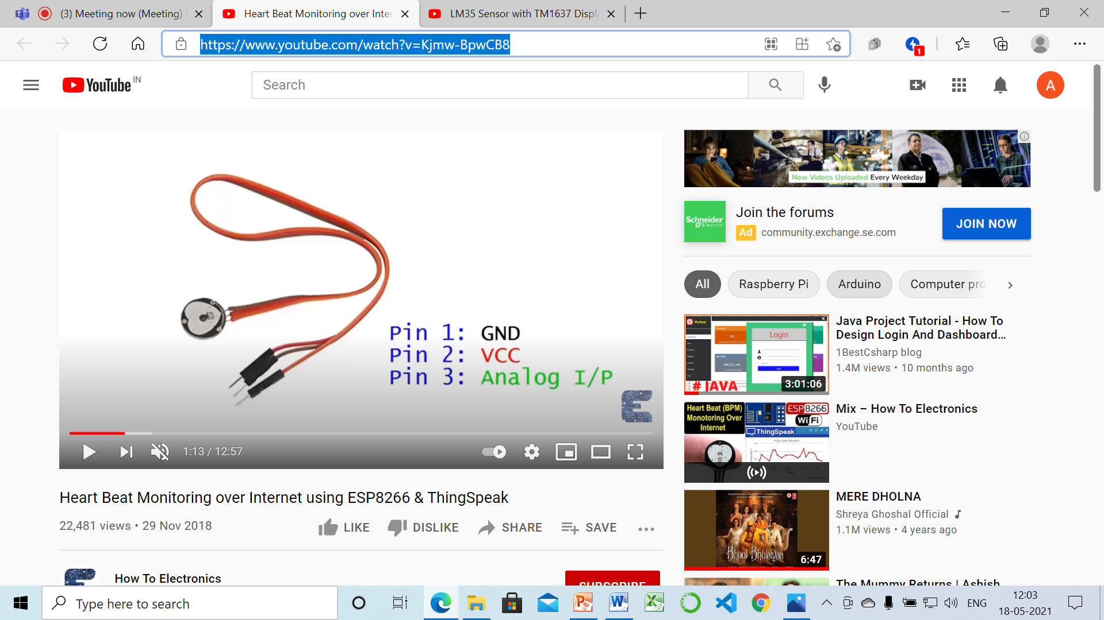

* **Gas cylinder leaks/ toxic gas emission**- MQ-9 Carbon Monoxide MQ 9 CO Alarm Combustible Gas (methane, propane and cryogenic cleaning gases) Sensor
* **Fire**- Flame sensor
* **Heart rate and Oxygen Saturation**- MAX30102 Blood Oxygen Concentration sensor

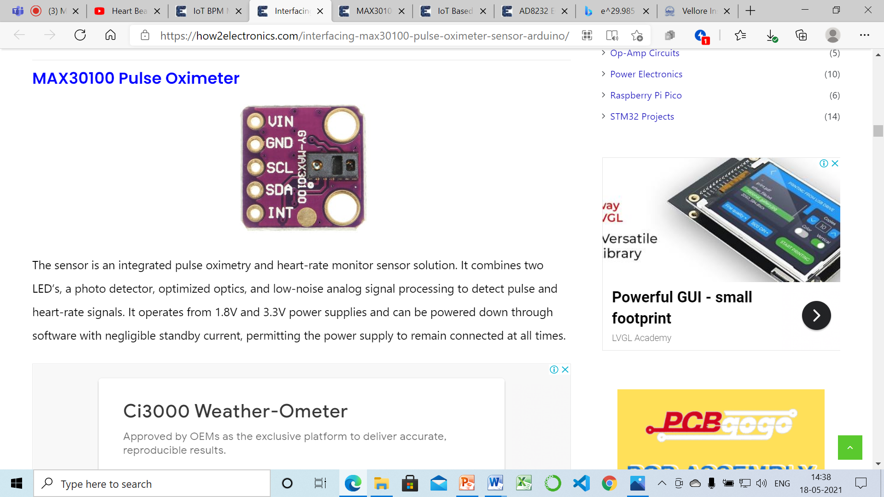

* **Fall detection**- ADXL335 3-Axis Accelerometer Module

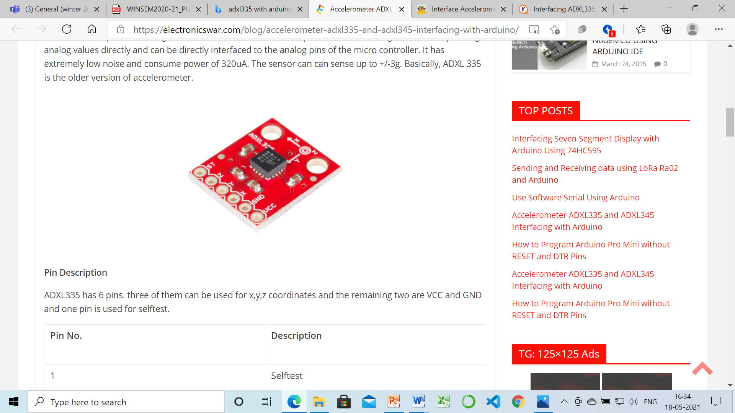

* **Heart ECG monitoring**- ECG Module AD8232 Sensor

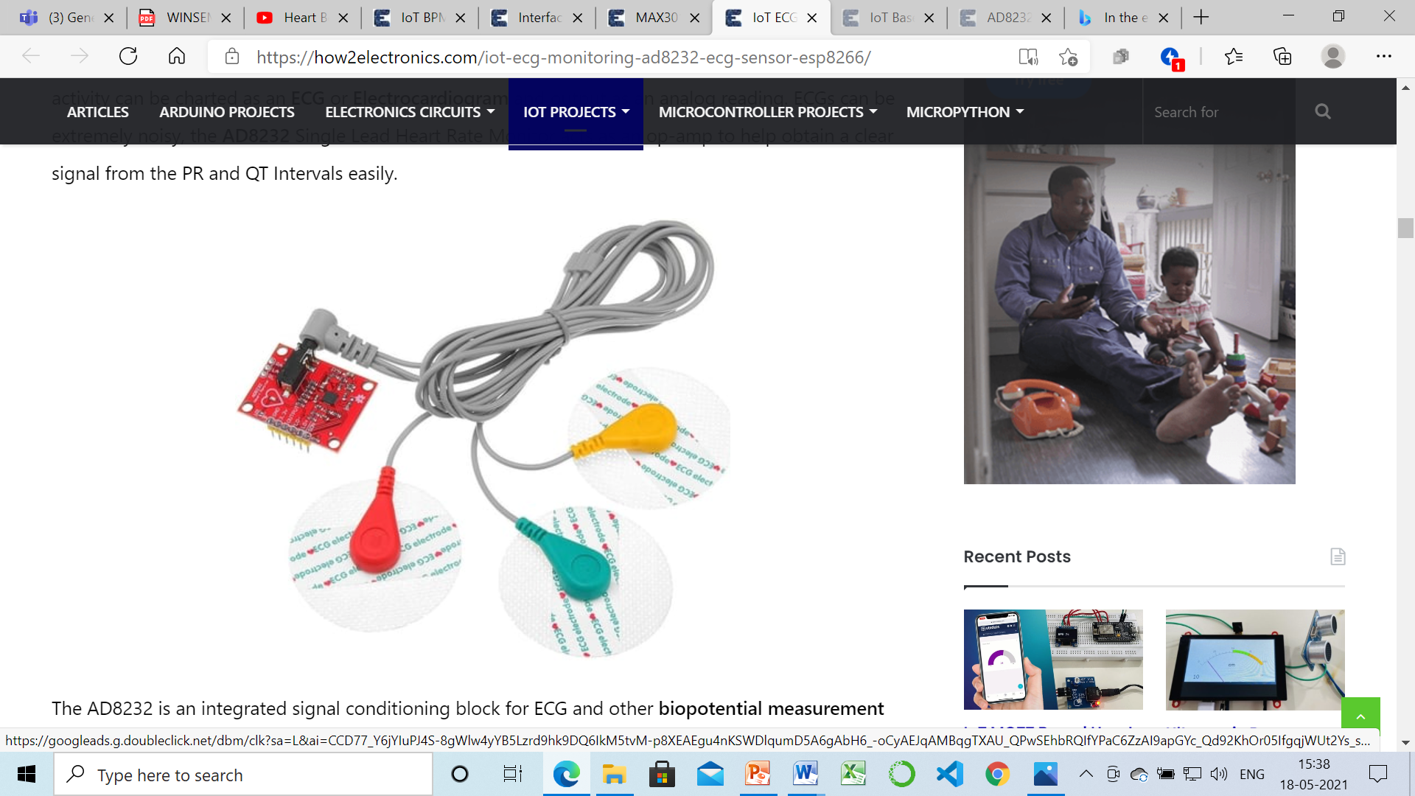

* **ESP8266 NODEMCU**- IoT based platform Wifi module. Helps is sending email and message notification to the people outside if their family member is in trouble at home.

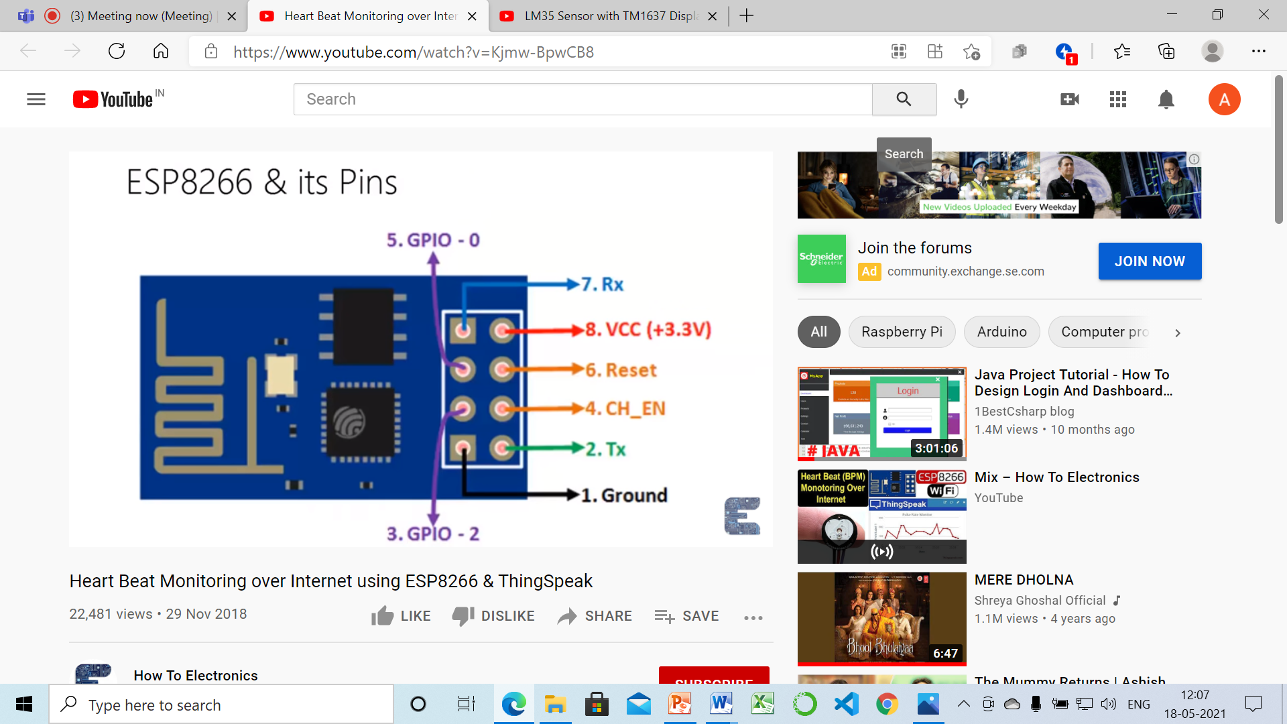

**[**Pin 1 : Ground : Connected to the ground of the circuit

Pin 2 : Tx/GPIO – 1 : Connected to Rx pin of programmer/uC to upload program

Pin 3 : GPIO – 2 : General purpose Input/output pin

Pin 4 : CH_EN : Chip Enable/Active high

Pin 5 : Flash/GPIO – 0 : General purpose Input/output pin

Pin 6 : Reset : Resets the module

Pin 7 : RX/GPIO – 3 : General purpose Input/output pin

Pin 8 : Vcc : Connect to +3.3V only**]**

* **App-**

To make graphs and keep a track of abnormalities, storing the health data collected. This data can be seen from any part of the world on Real time basis.

**ThinkSpeak:** ThingSpeak is an open-source Internet of Things (IoT) application and API to store and retrieve data from things using the HTTP protocol over the Internet or via a Local Area Network.

**MIT app inventor**

**Flutter**

**ESPAsyncWebServer library**

**Freeboard.io:** A digital dashboard called Freeboard.io is used to monitor the sensor data visually online.

**Blynk application**

* This kit will also help in easy check-up and health data monitoring of paralyzed person or old people. Any abnormalities can be immediately addressed on time.
* **Real time Remote healthcare monitoring achieved**
* Saves money as it is not very costly. If people buy each and every device for measuring each and every health parameter, or summing up their yearlong testing costs, check-up costs and travelling cost( the cost of travelling to the testing centre or calling someone to come home and check) then cost will be way more than this device that I am planning to make as it is an **INTEGRATED HEALTHCARE SOLUTION FOR ALL**

**Who is currently facing this issue (target audience)?**

Everyone

**Specially:** Old-aged and Paralyzed patients

**How is the issue being addressed currently?**

Many companies are bringing out gadgets and devices that can be used at home for medical checkups. But these are all different devices for different purposes, like for bp measurement one device, for ecg another, for sugar another. Hence it is inconvenient for the people to buy so many devices and use them. Many don't understand the working and it is cost ineffective. There is no overall integrated solution.

**My Role in the Project:**

The project was individually made by me.

**What I learned During the project?**

IoT concepts, Hardwares

About various sensors

**Courses I took while working for this project:**

I studied from Youtube videos and various sites.

**Libraries Installed:**

**GitHub Repo Link:**

**Workflow of Model:**

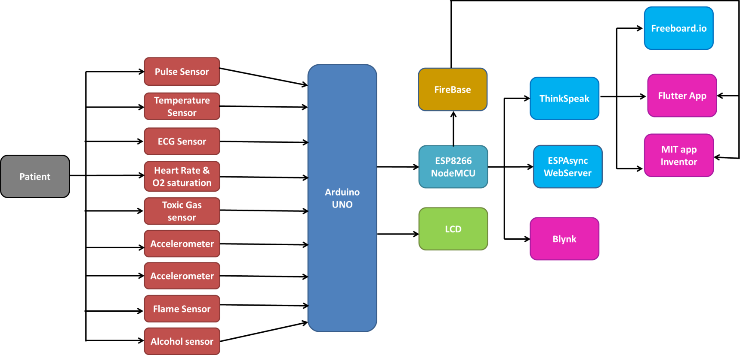

**CIRCUIT AND CONNECTIONS:**

1. **Pulse+Temperature**



1. Connect Pulse Sensor output pin to A0 of Arduino and other two pins to VCC & GND.
2. Connect LM35 Temperature Sensor output pin to A1 of Arduino and other two pins to VCC & GND.
3. Connect the LED to Digital Pin 7 of Arduino via a 220-ohm resistor.
4. Connect Pin 1,3,5,16 of LCD to GND.
5. Connect Pin 2,15 of LCD to VCC.
6. Connect Pin 4,6,11,12,13,14 of LCD to Digital Pin12,11,5,4,3,2 of Arduino.
7. The RX pin of ESP8266 works on 3.3V and it will not communicate with the Arduino when we will connect it directly to the Arduino. So, we will have to make a voltage divider for it which will convert the 5V into 3.3V. This can be done by connecting the 2.2K & 1K resistor. Thus the RX pin of the ESP8266 is connected to pin 10 of Arduino through the resistors.
8. Connect the TX pin of the ESP8266 to pin 9 of the Arduino.
9. **Heart Rate+ Oxygen Saturation**

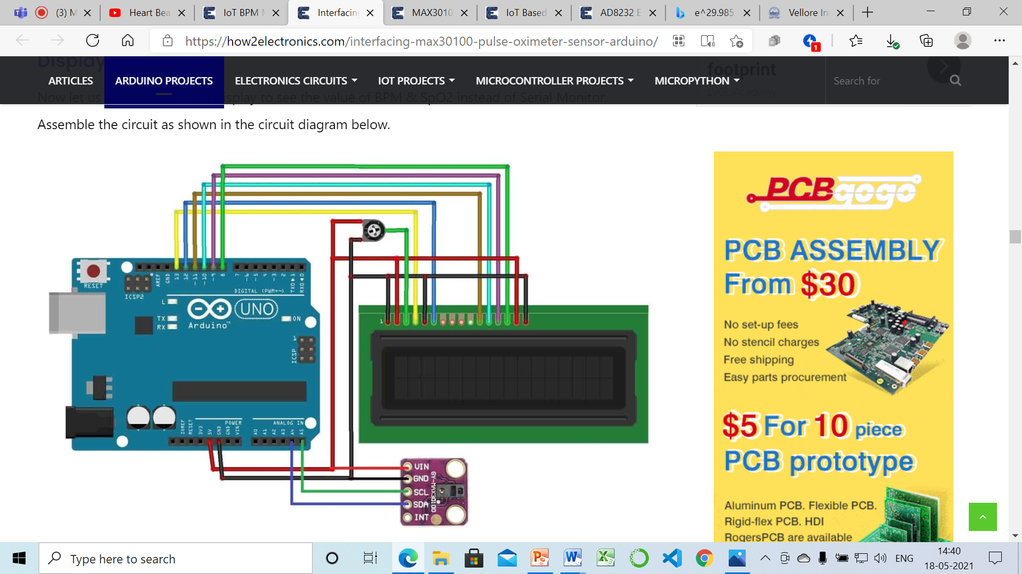

1. Connect the Vin pin of MAX30100 to Arduino 5V or 3.3V pin,
2. GND to GND.
3. Connect the I2C Pin, SCL & SDA of MAX30100 to A5 & A4 of Arduino.
4. Similarly connect the LCD pin 1, 5, 16 to GND of Arduino and
5. 2, 15 to 5V VCC.
6. Similarly connect LCD pin 4, 6, 11, 12, 13, 14 to Arduino pin 13, 12, 11, 10, 9, 8. Use 10K Potentiometer at pin 3 of LCD to adjust the contrast of LCD.